**Group 294: Crop Yield Prediction**

**Output Snapshots Content:**

* **Data Preprocessing**
  + - * **Memory Optimization**
      * **Converting date, timestamp to datetime format**
      * **Checking and clearing duplicates**
      * **Null Values**
      * **Merge operation**
      * **Removed Outliers**
      * **Dropping unnecessary columns**
      * **Label encoding**
* **Data Visualization**
* **Extracting features from date and time**
  + - * **Timestamps**
      * **Weekend or not**
      * **Morning Evening night**
* **Models**
  + - * + **Linear Regression**
        + **Decision Tree**

**Without Outliers**

**Hyperparameter**

* + - * + **Random Forest**
        + **XG Boost**
        + **Neural Network**
* **Comparison of Models**
* **Yield Production Graph**

**Snapshots of Outputs:**

1. **Data Preprocessing**

**Memory Optimization**

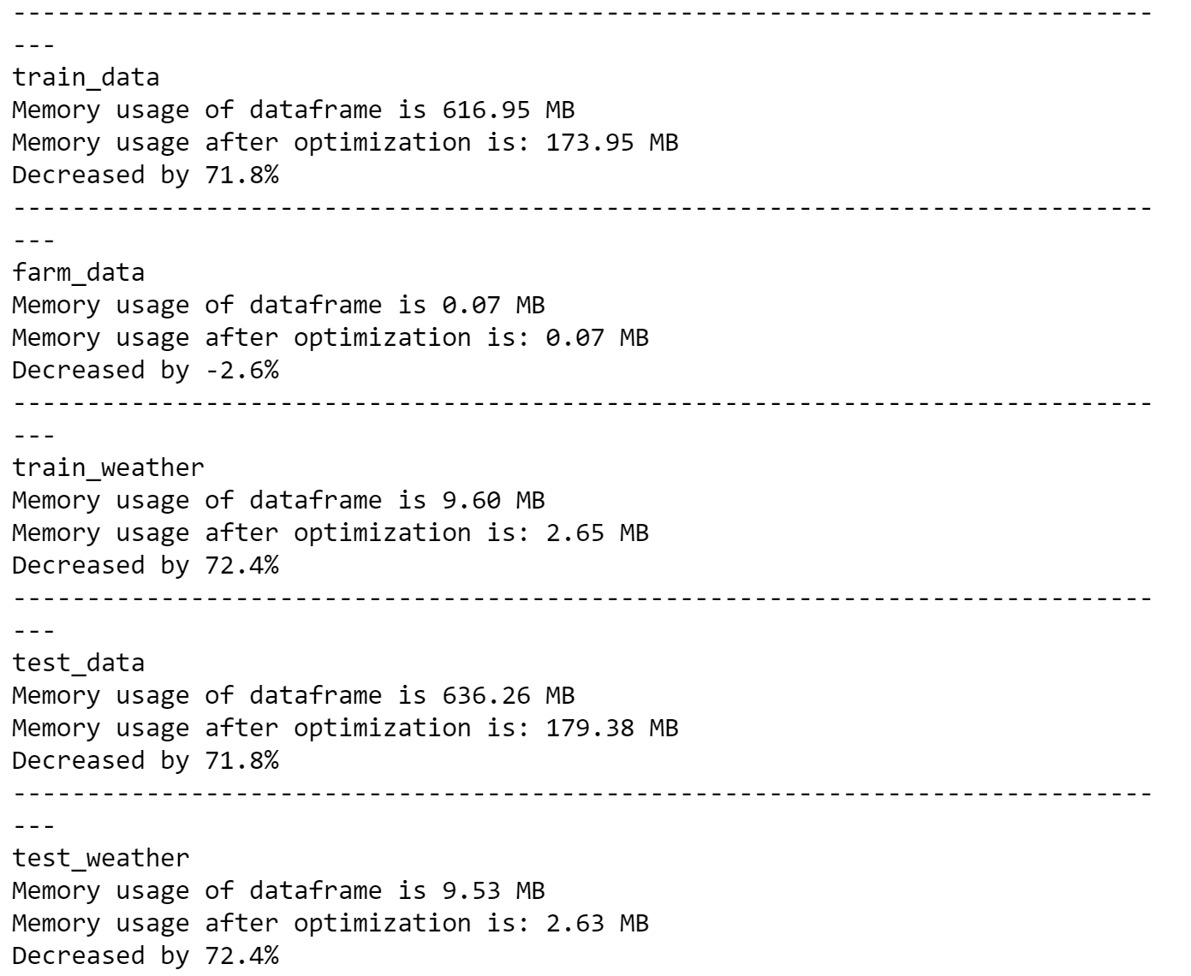

**Converting date, timestamp to datetime format**

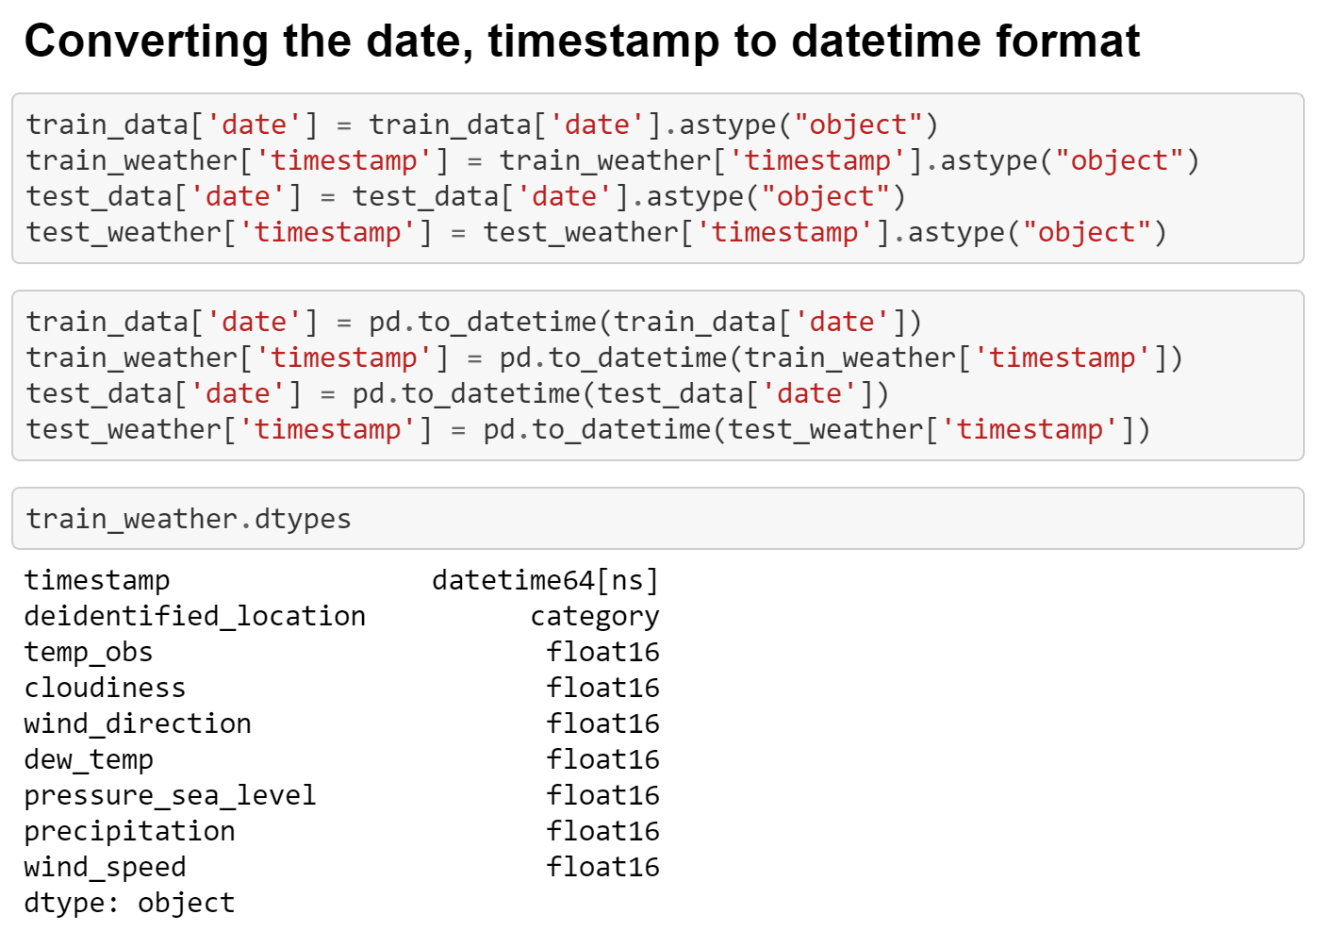

**Checking and clearing duplicates**

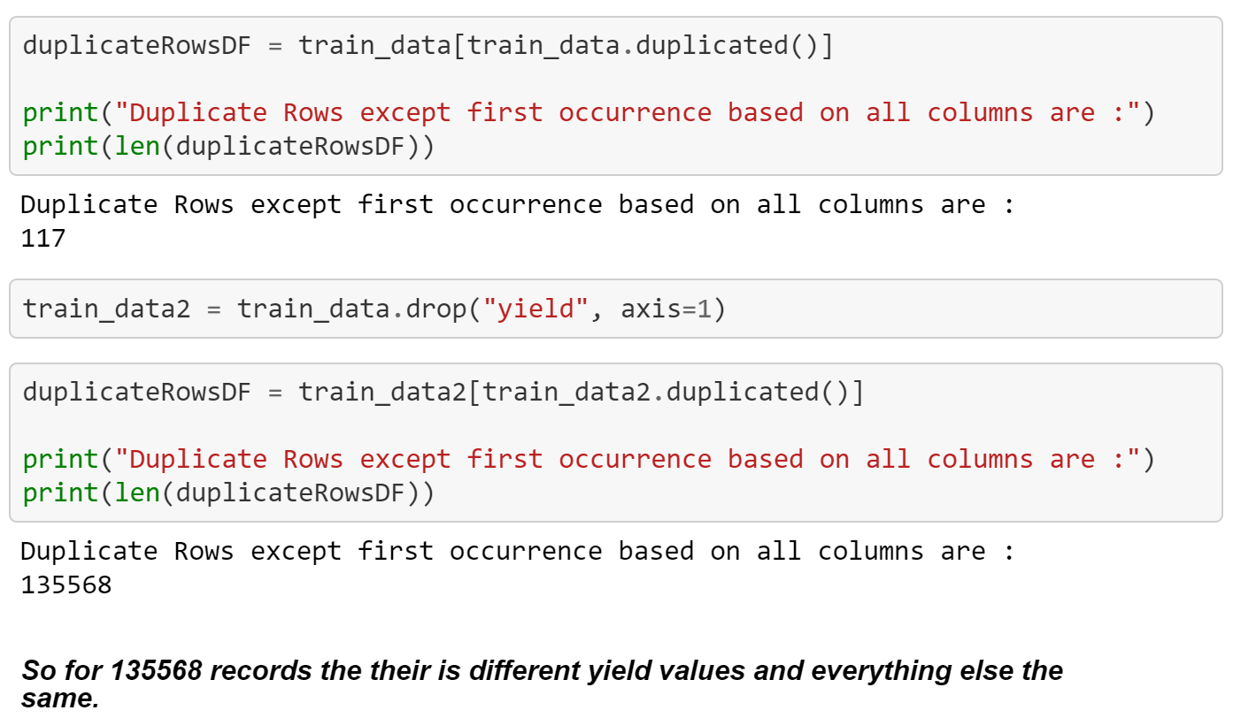

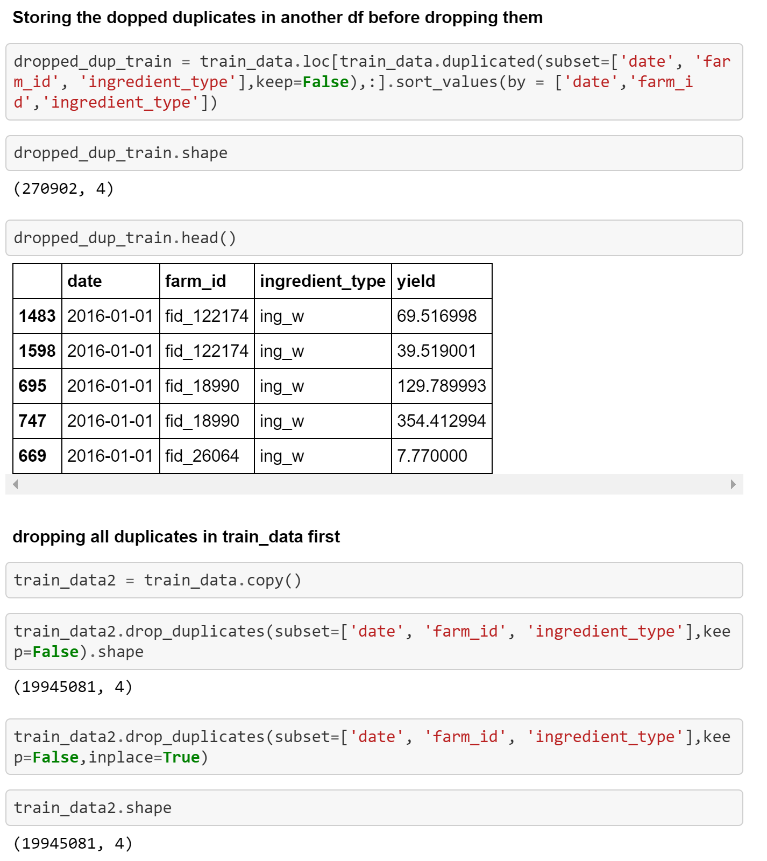

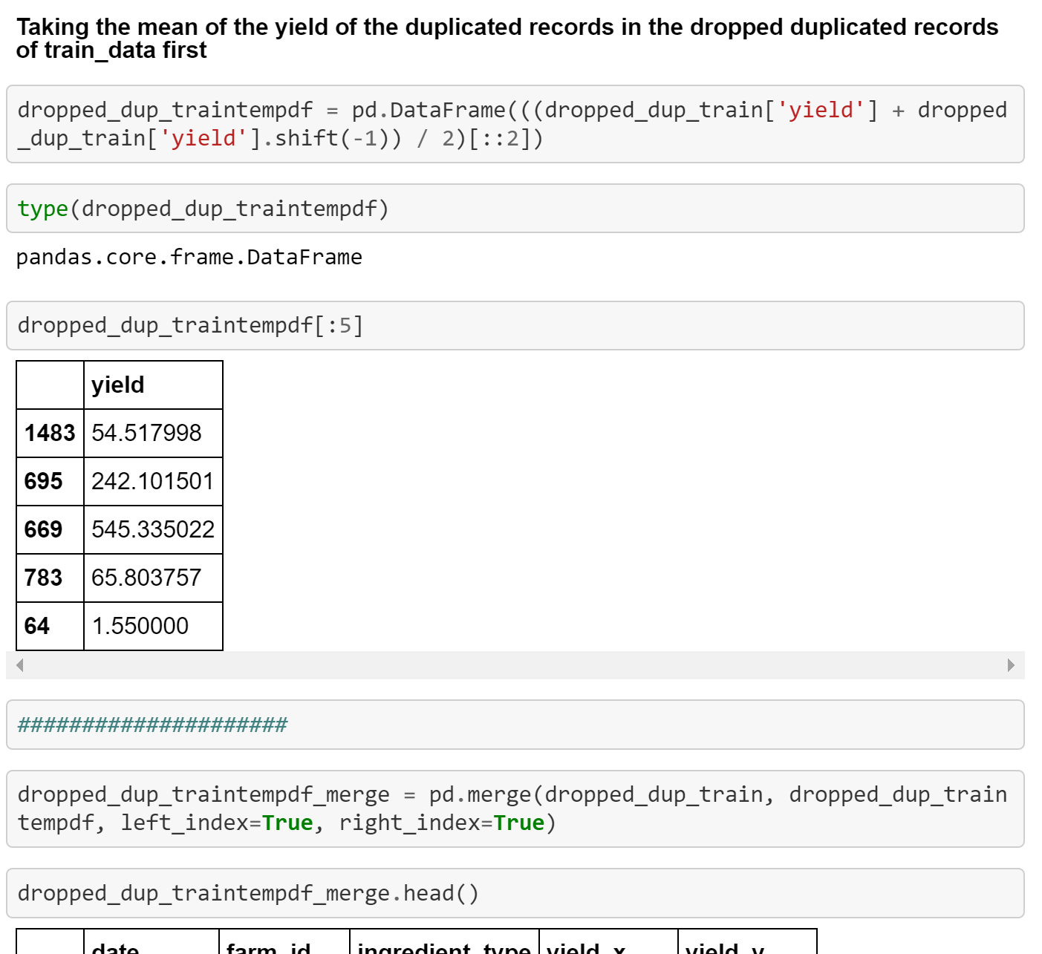

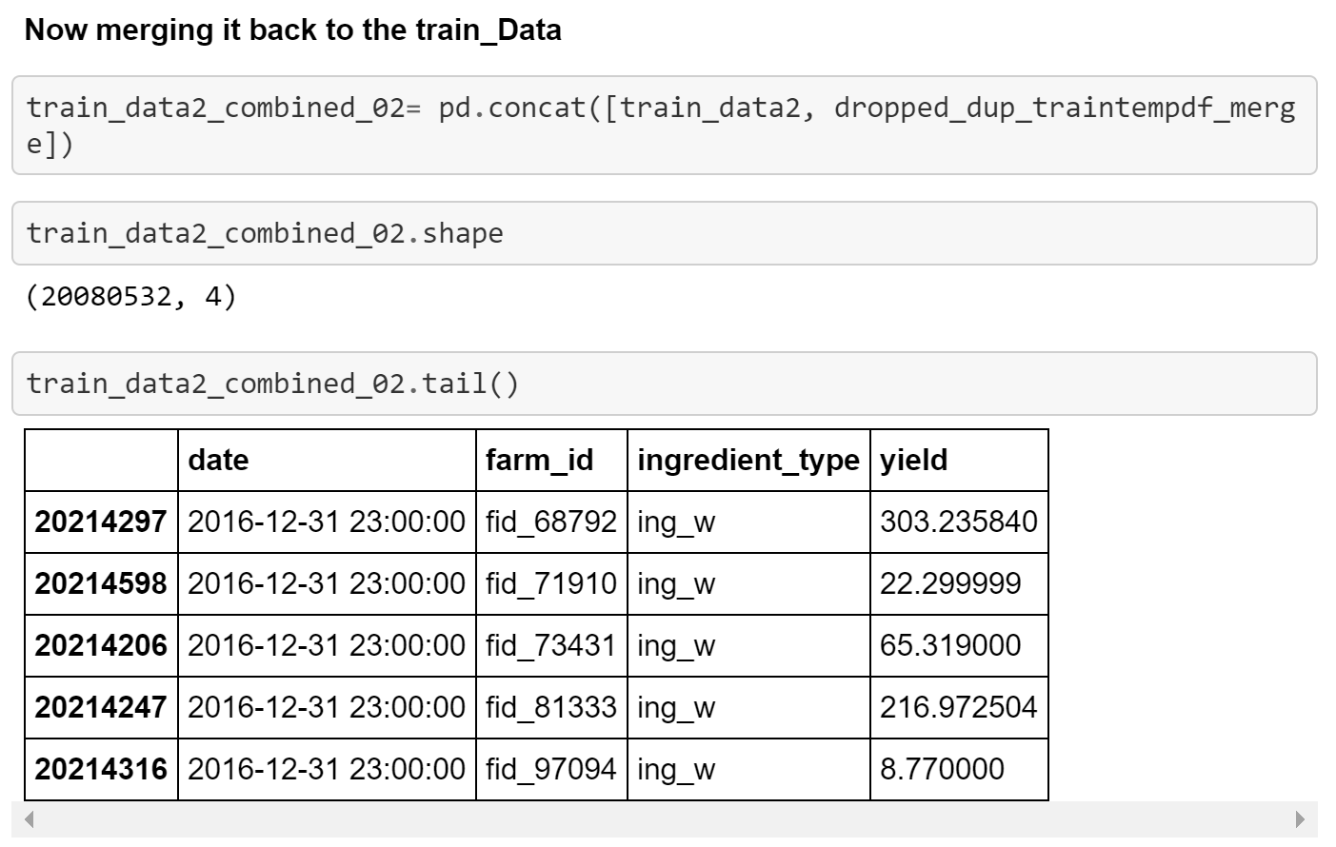

**Null Values**

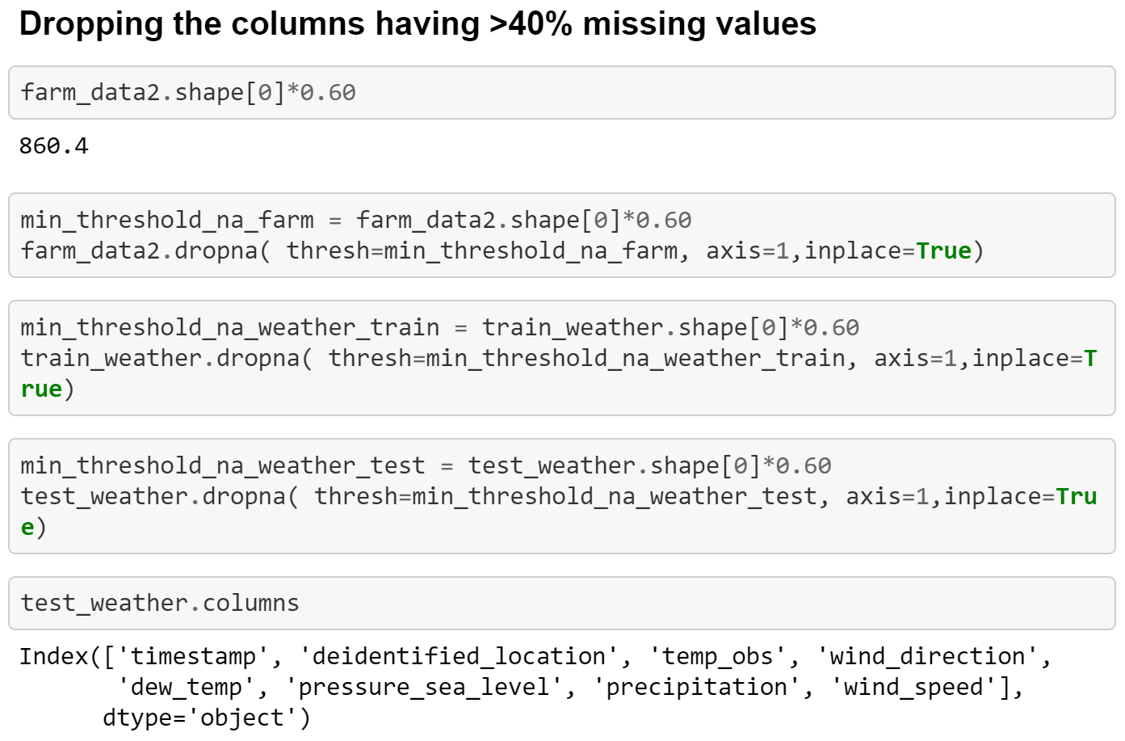

**Merge operation**

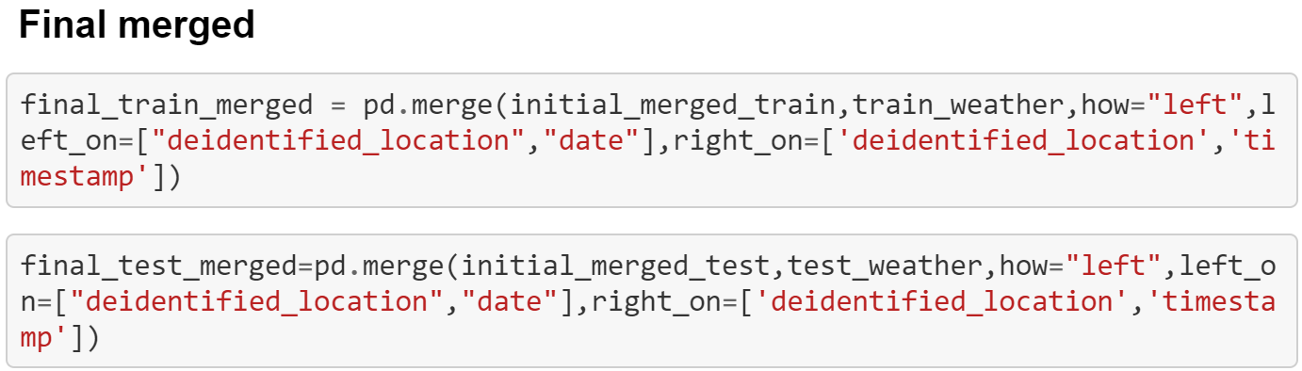

**Removed Outliers**

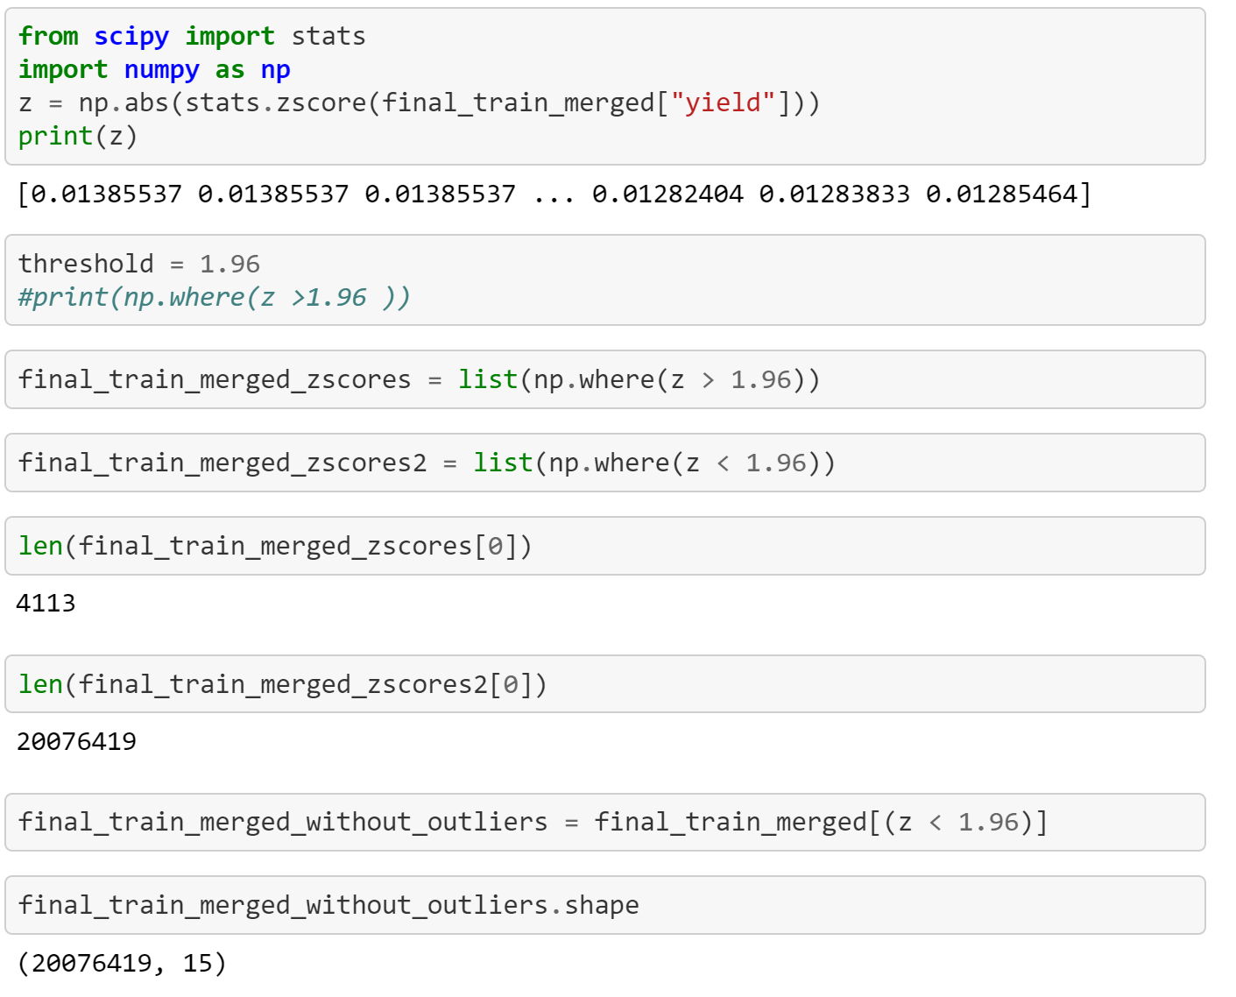

**Dropping unnecessary columns**

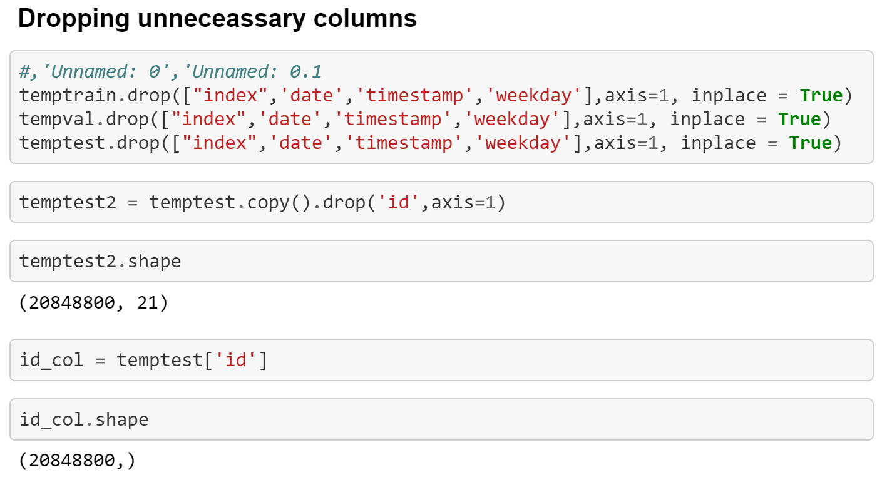

**Label encoding**

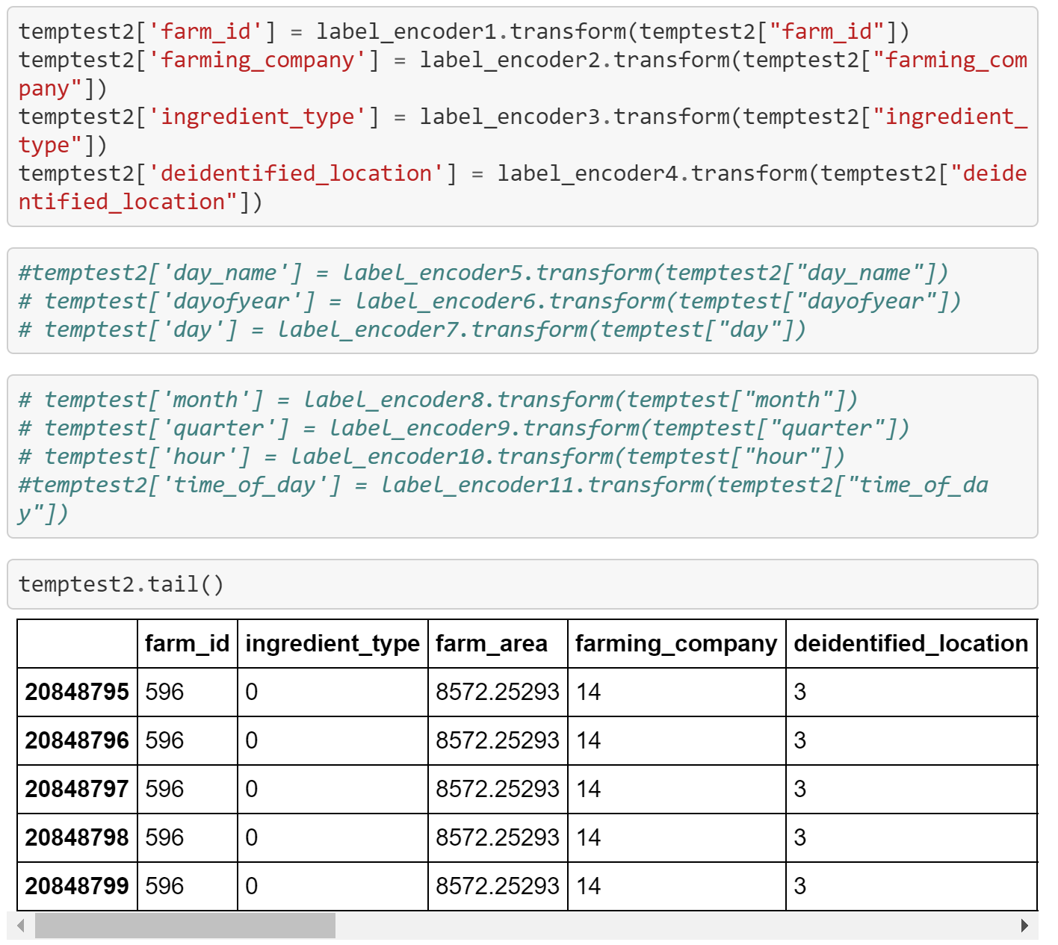

1. **Data Visualization**

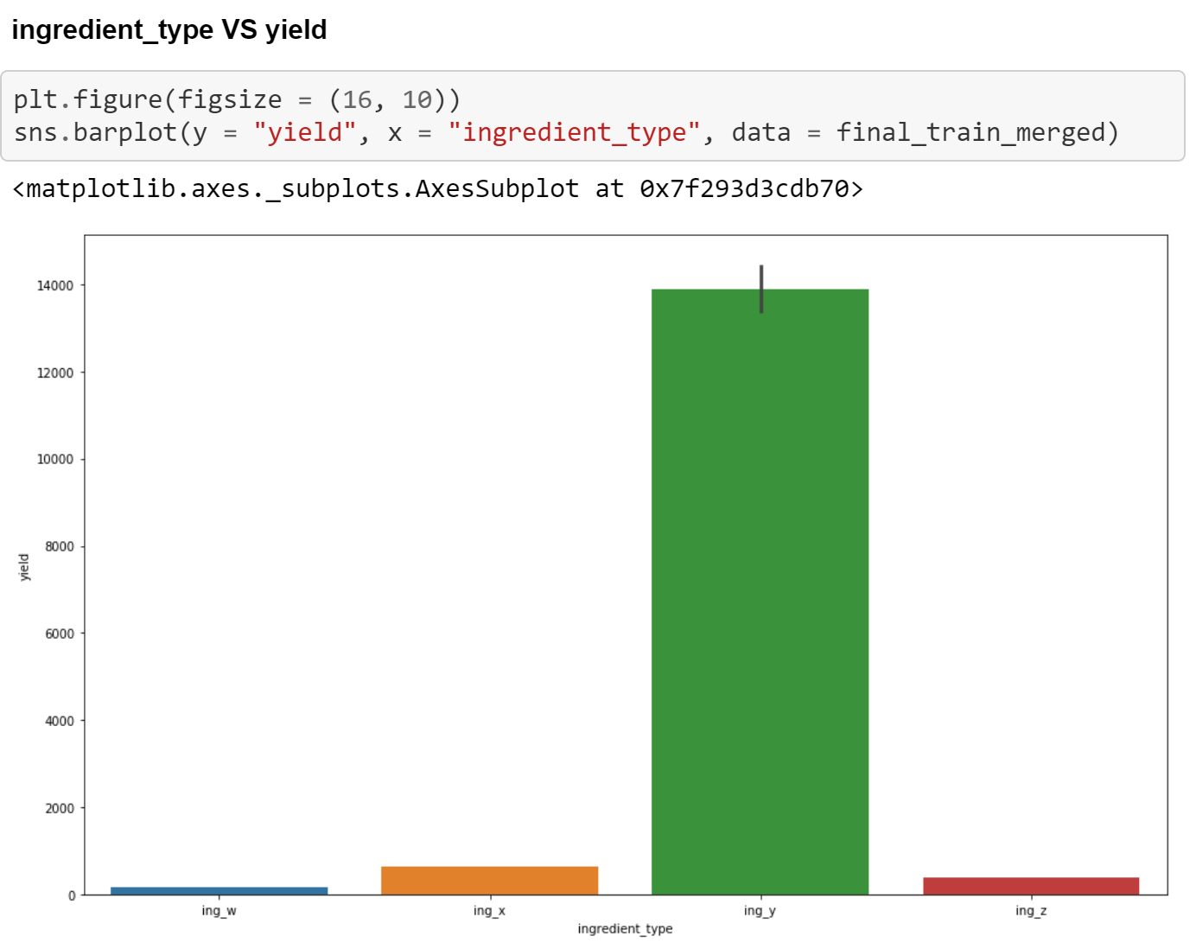

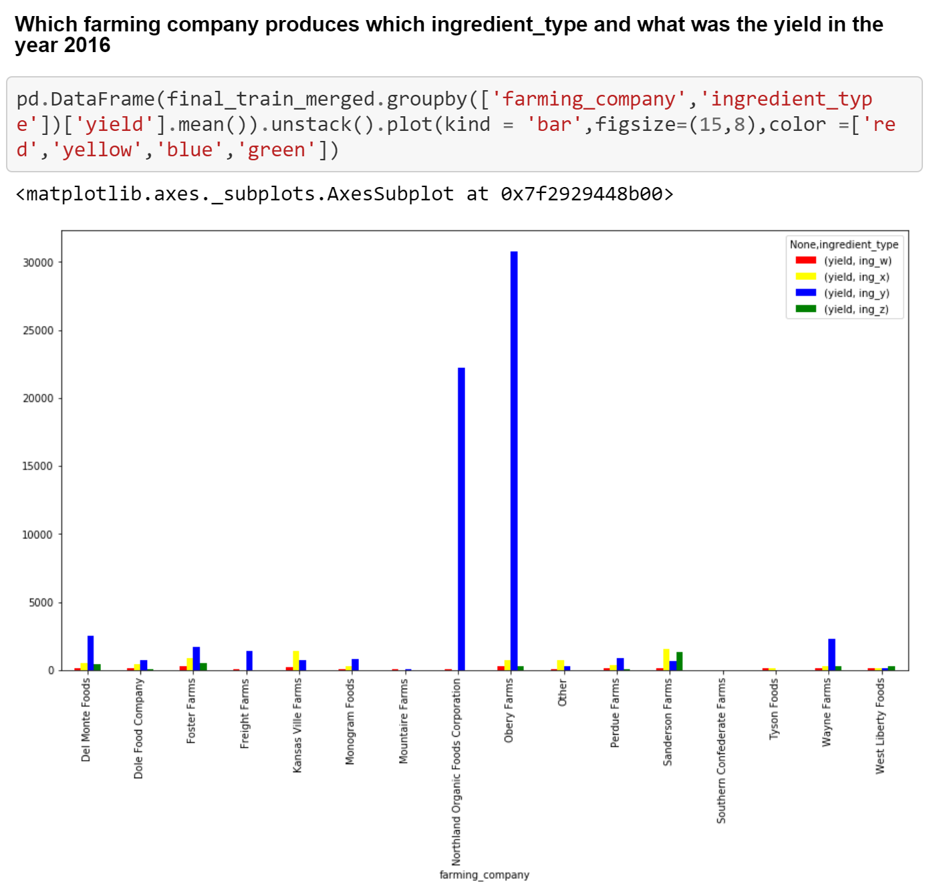

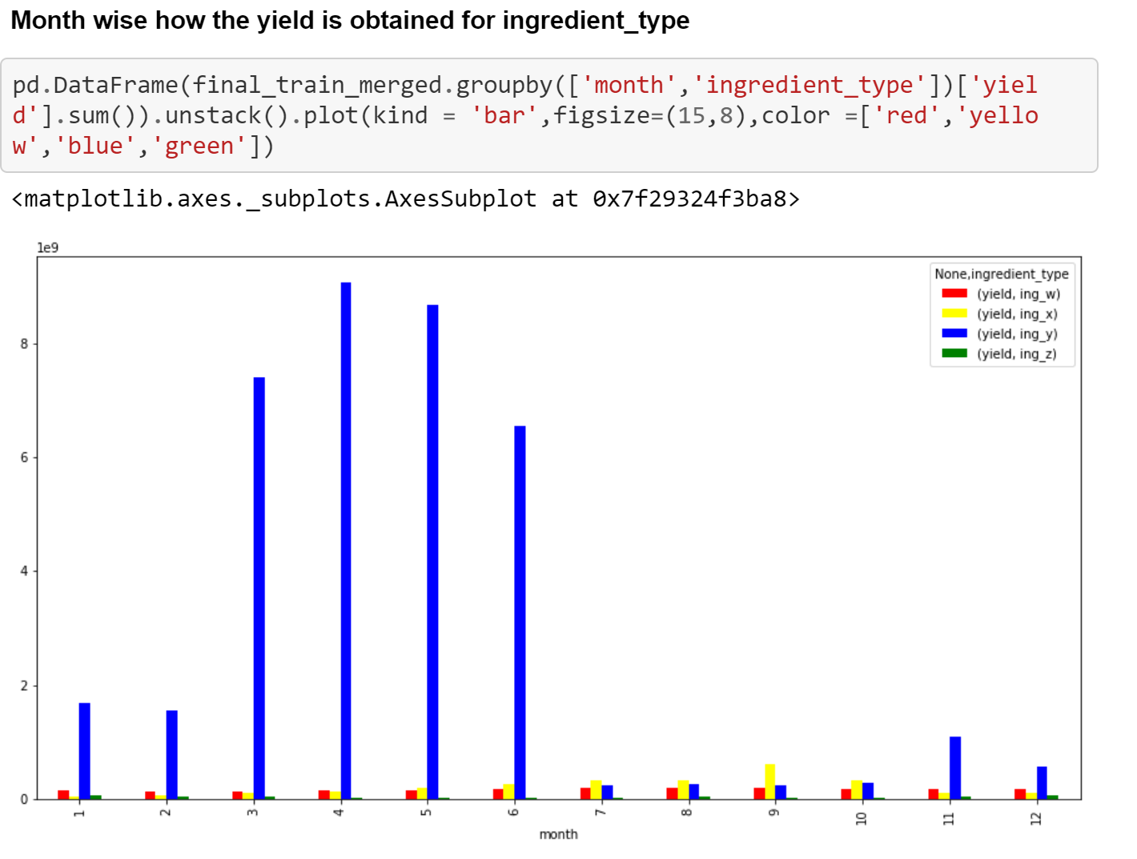

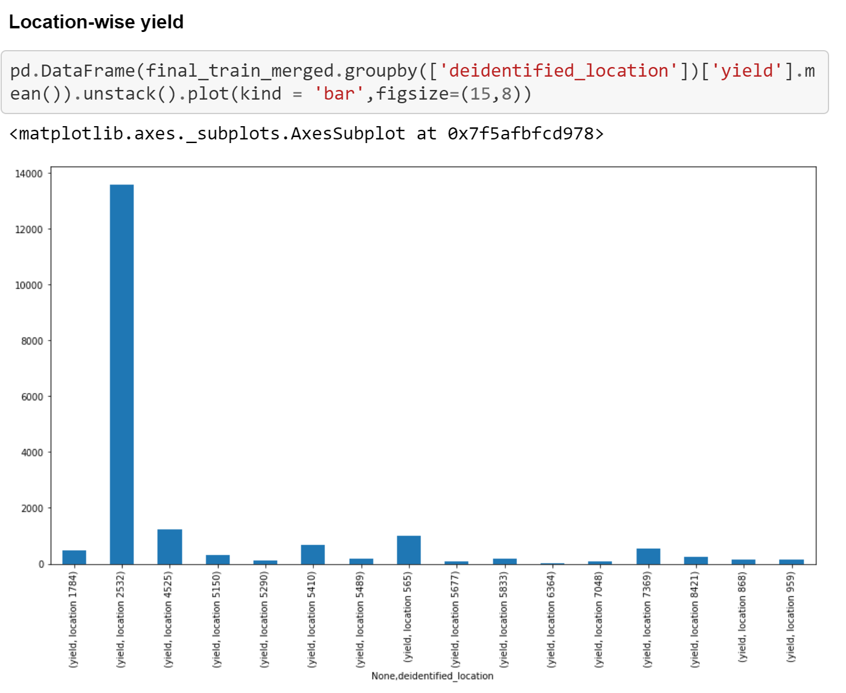

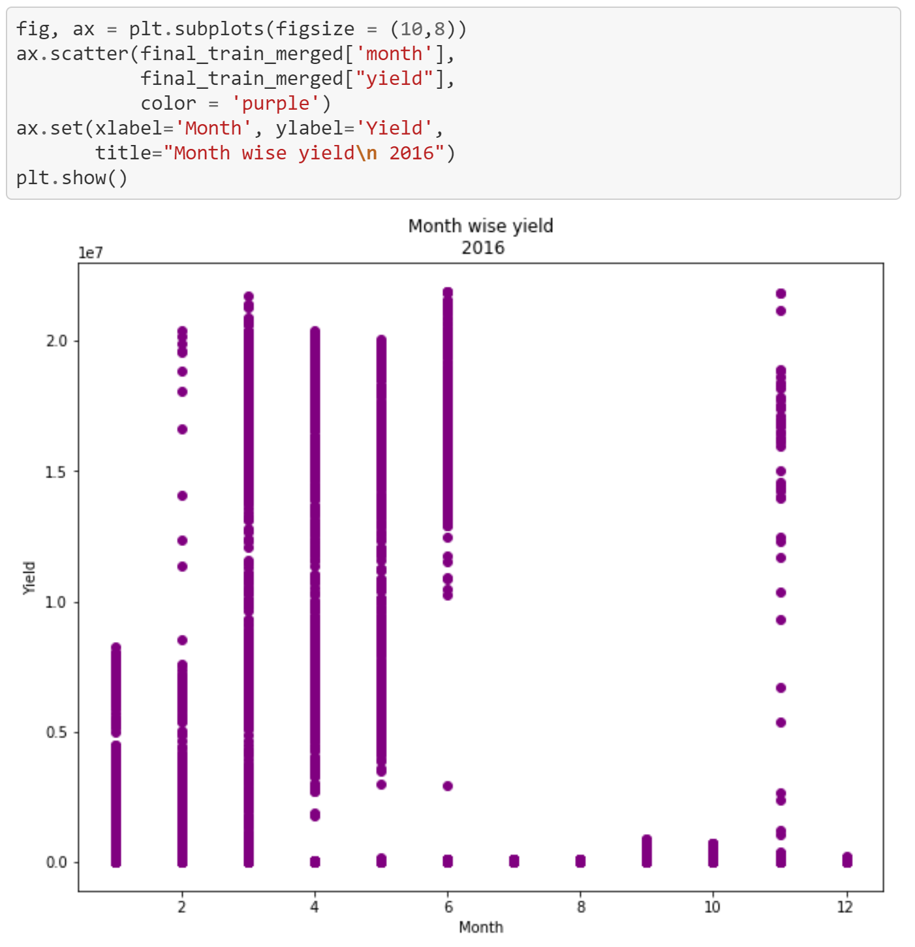

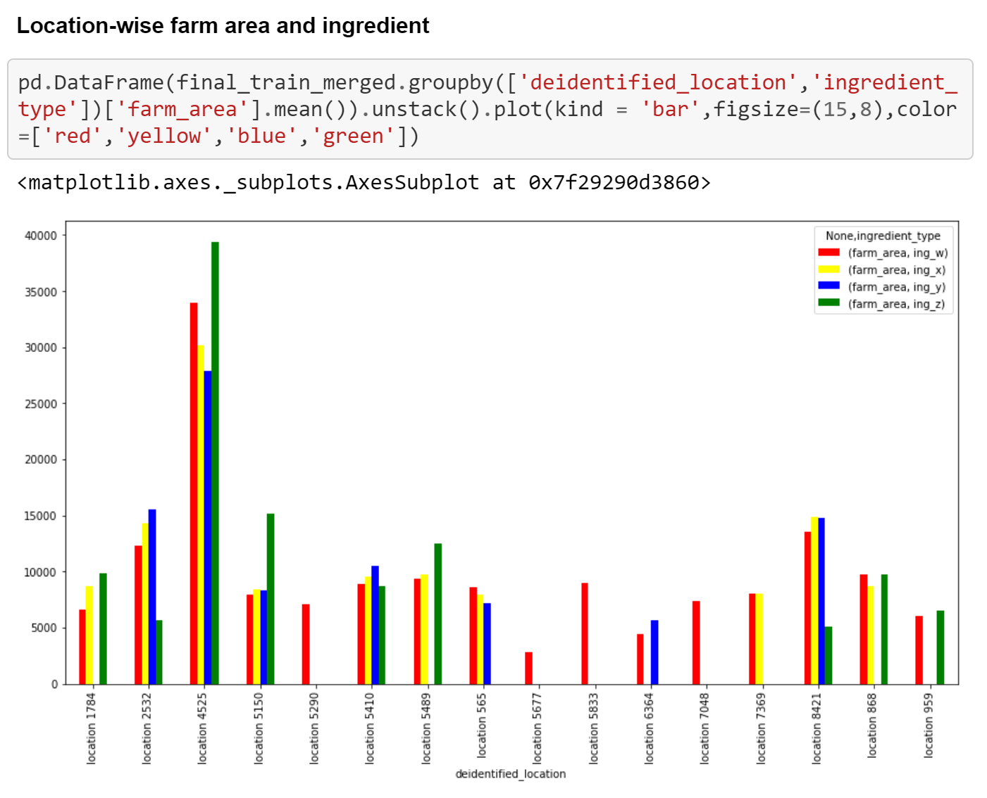

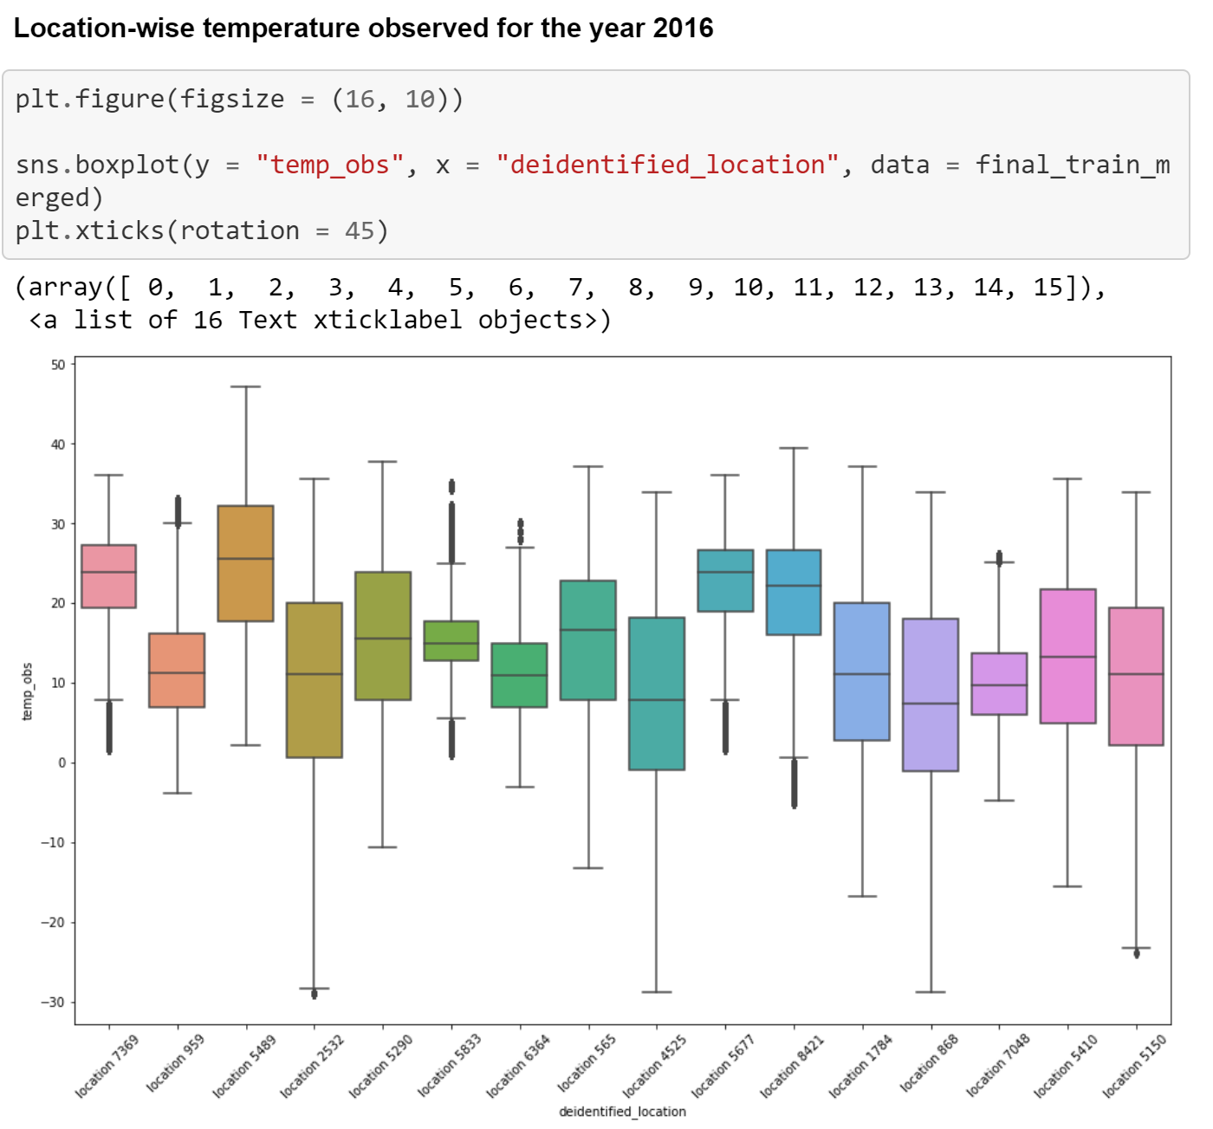

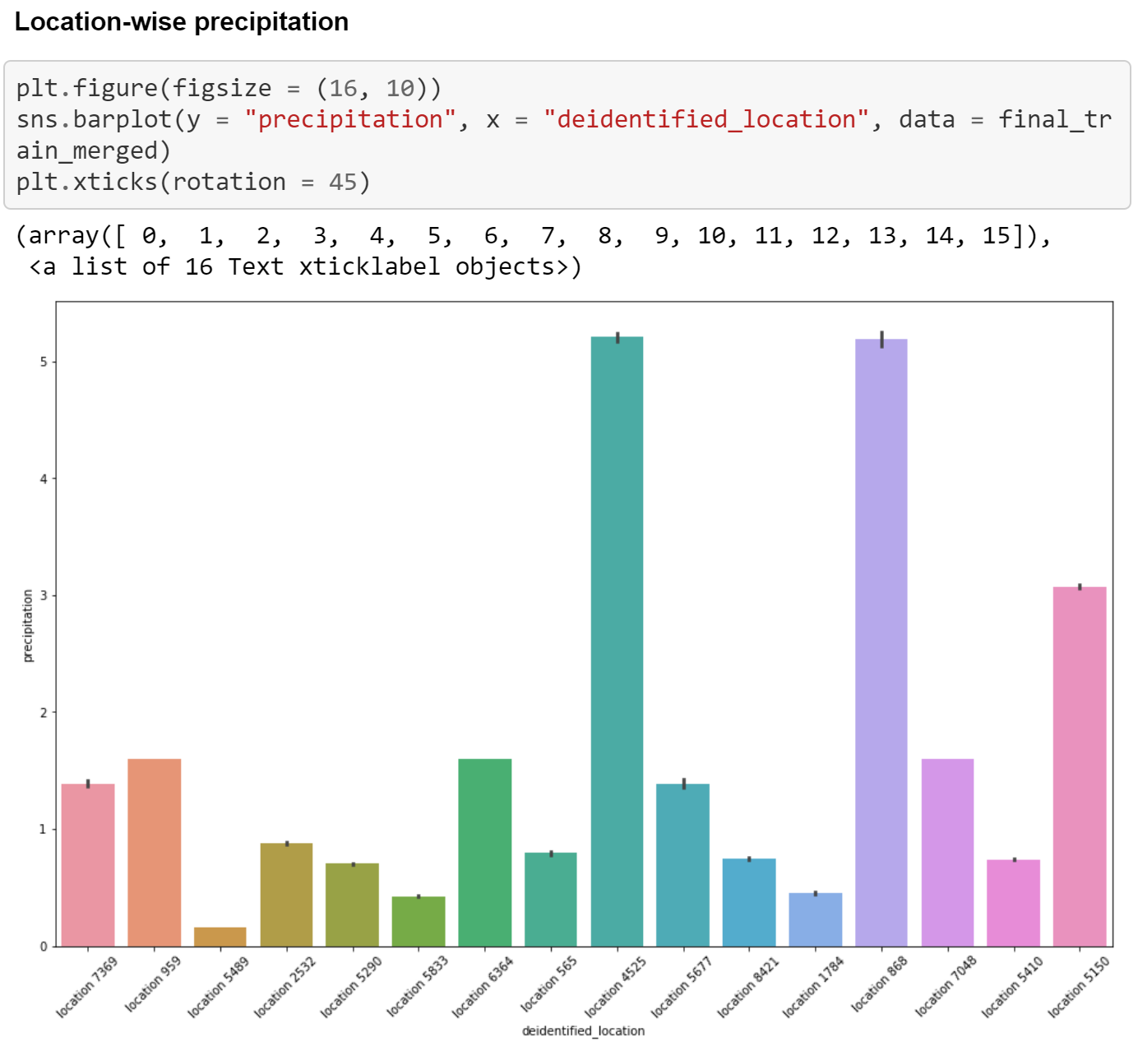

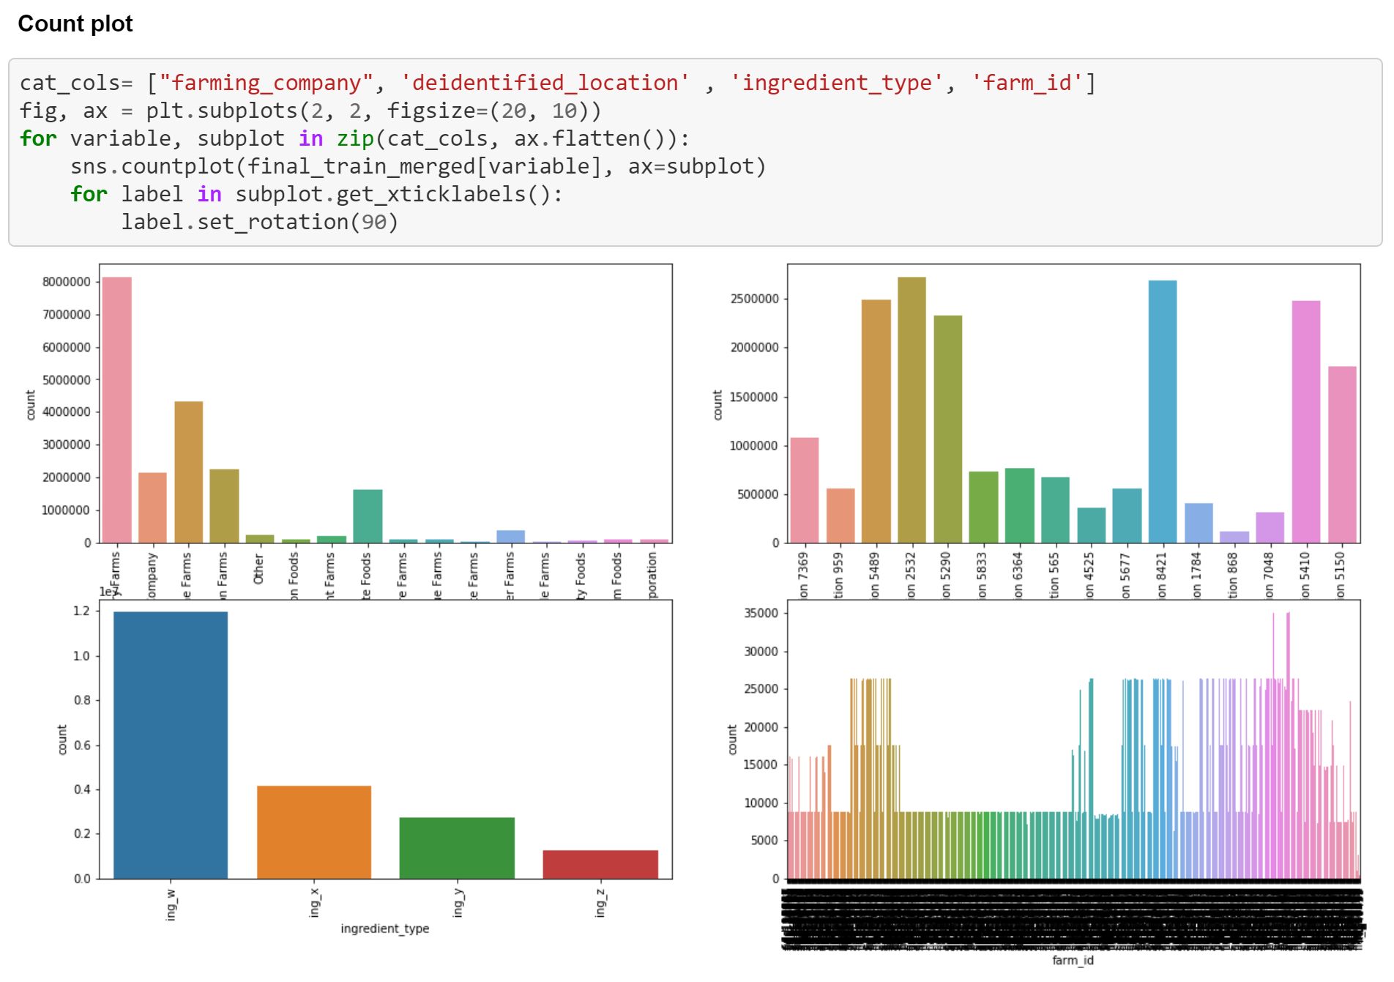

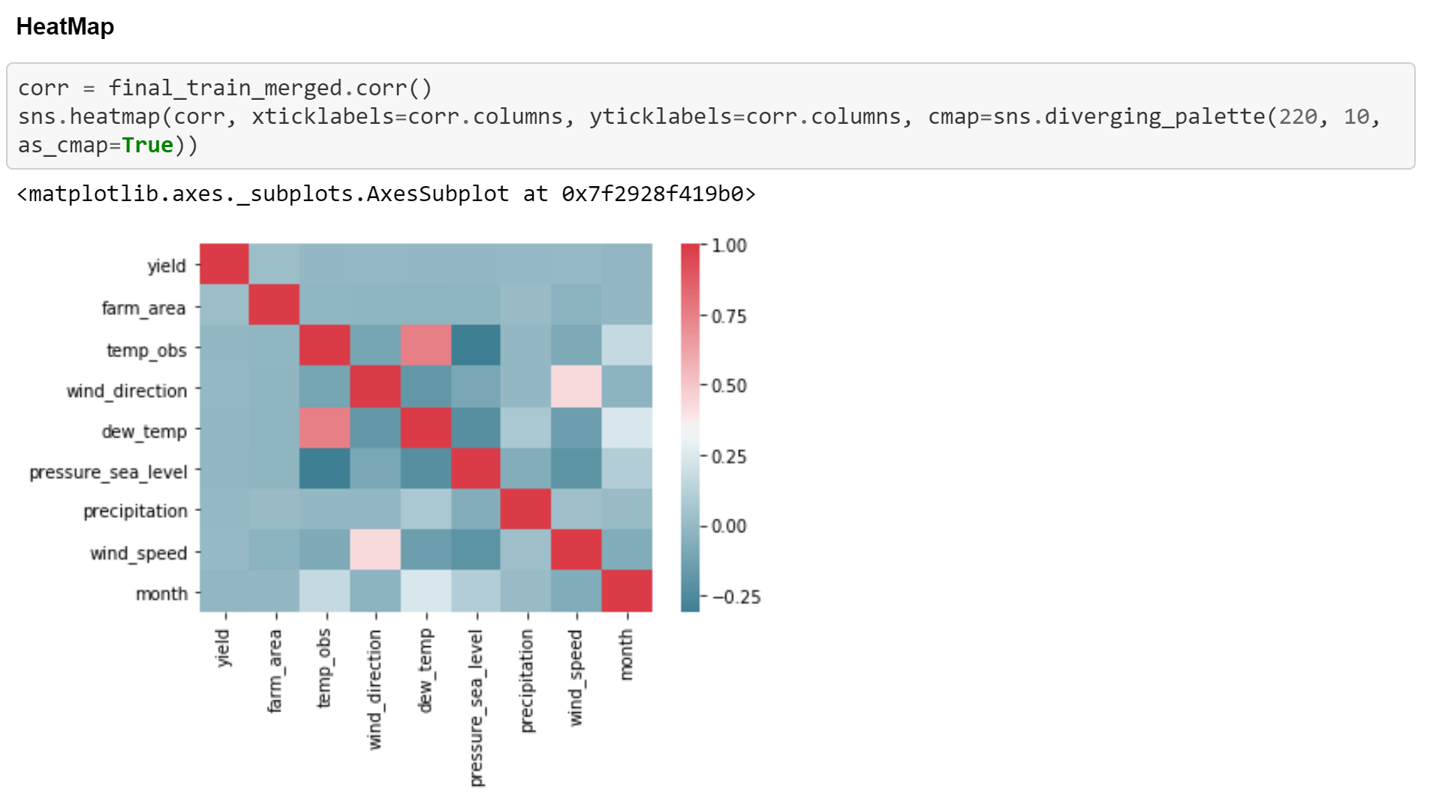

1. **Extracting features from date and time**

**Weekend or not**

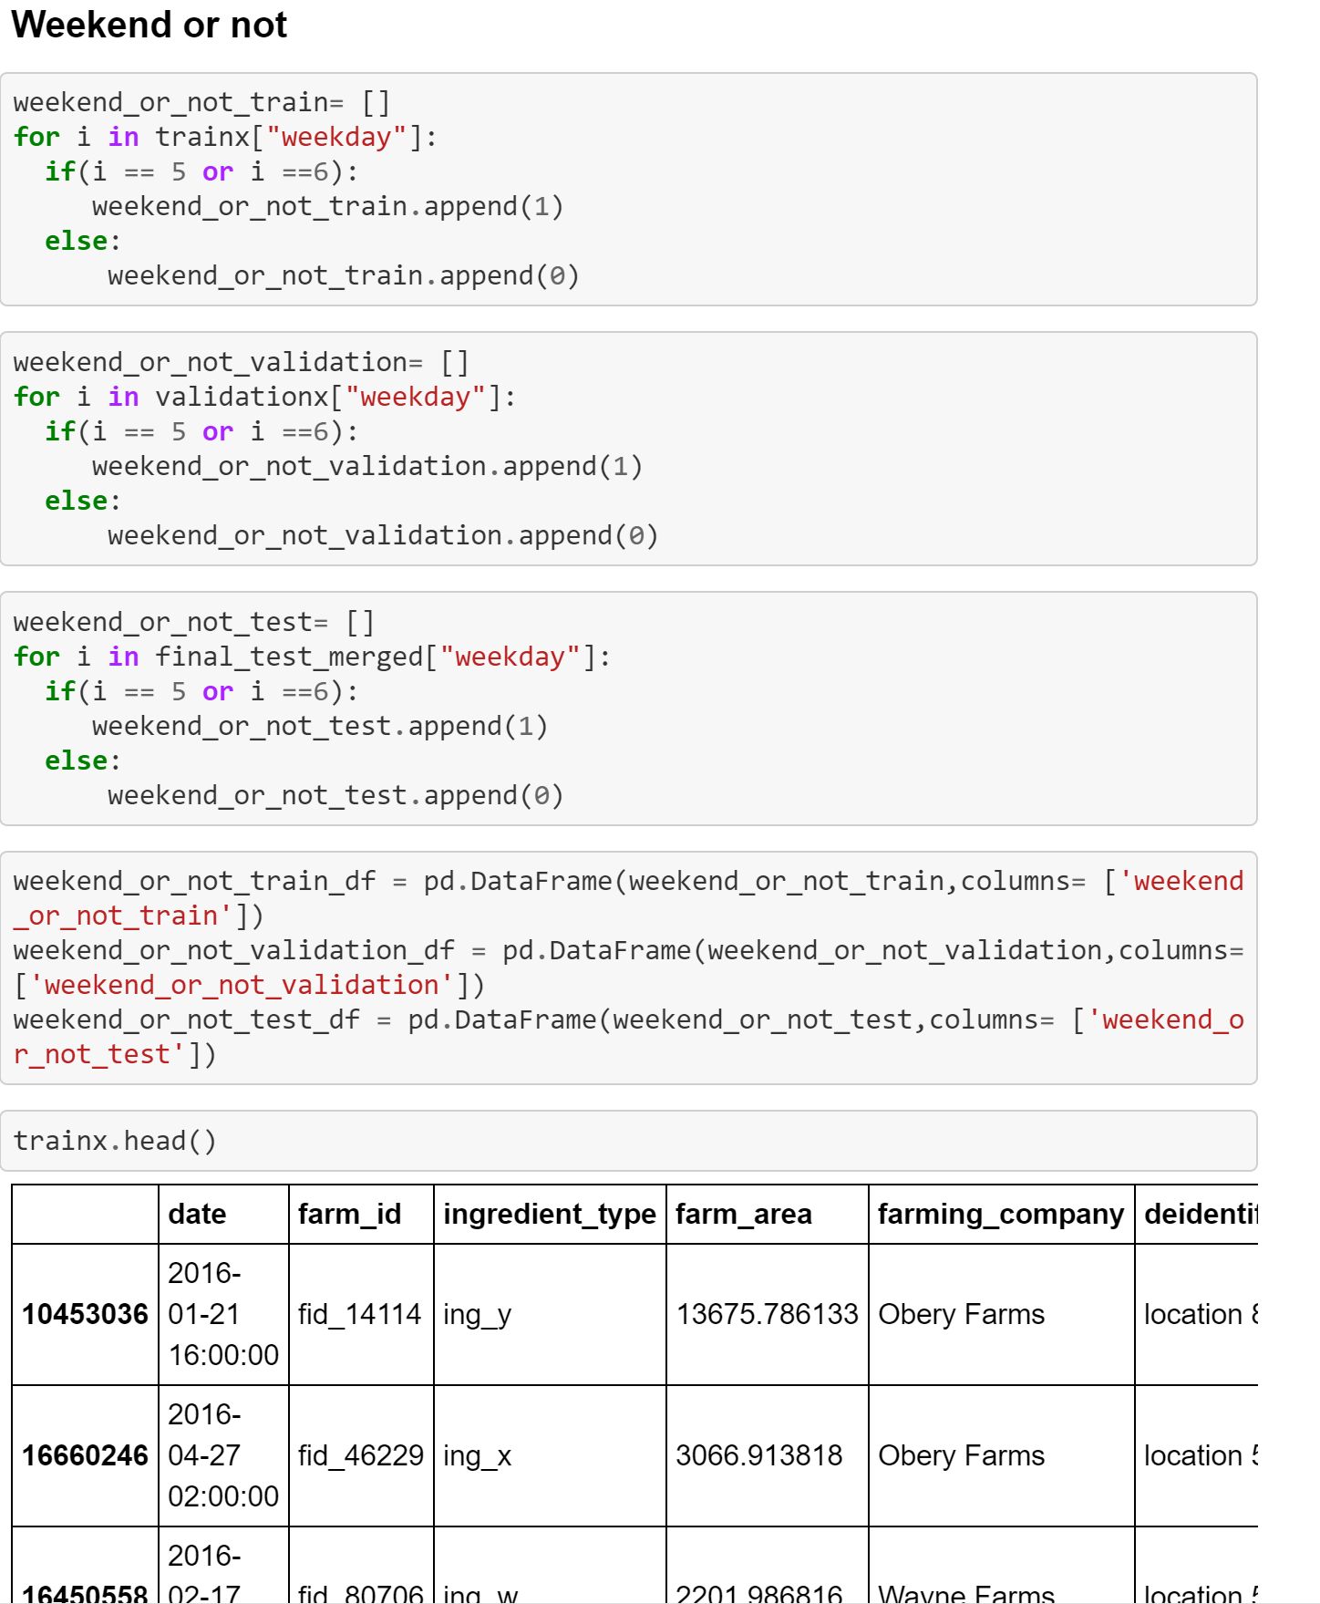

**Morning Evening night**

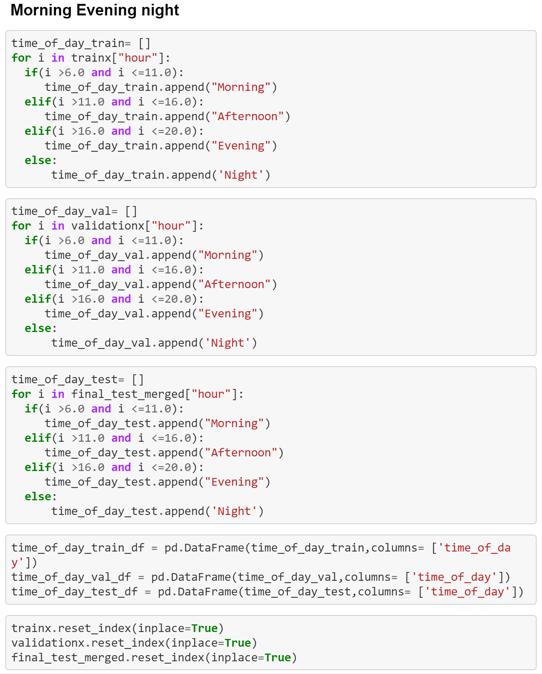

1. **Models**
   1. **Linear Regression**

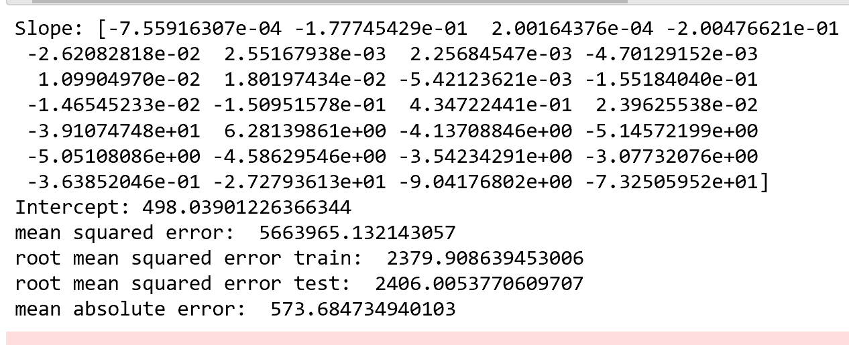

* 1. **Decision Tree** 
     1. **without outlier**

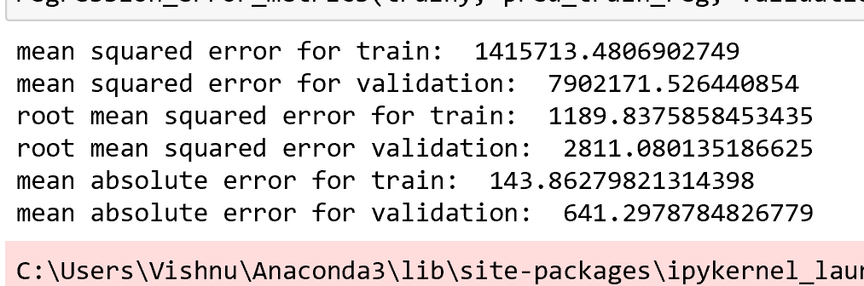

* + 1. **Hyperparameter**

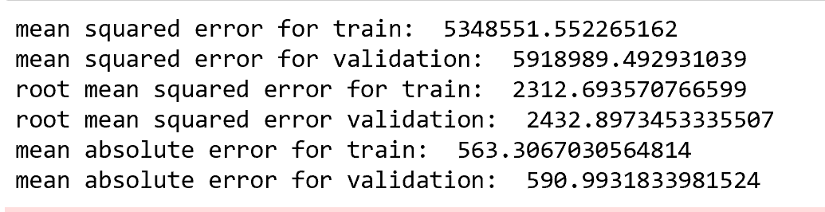

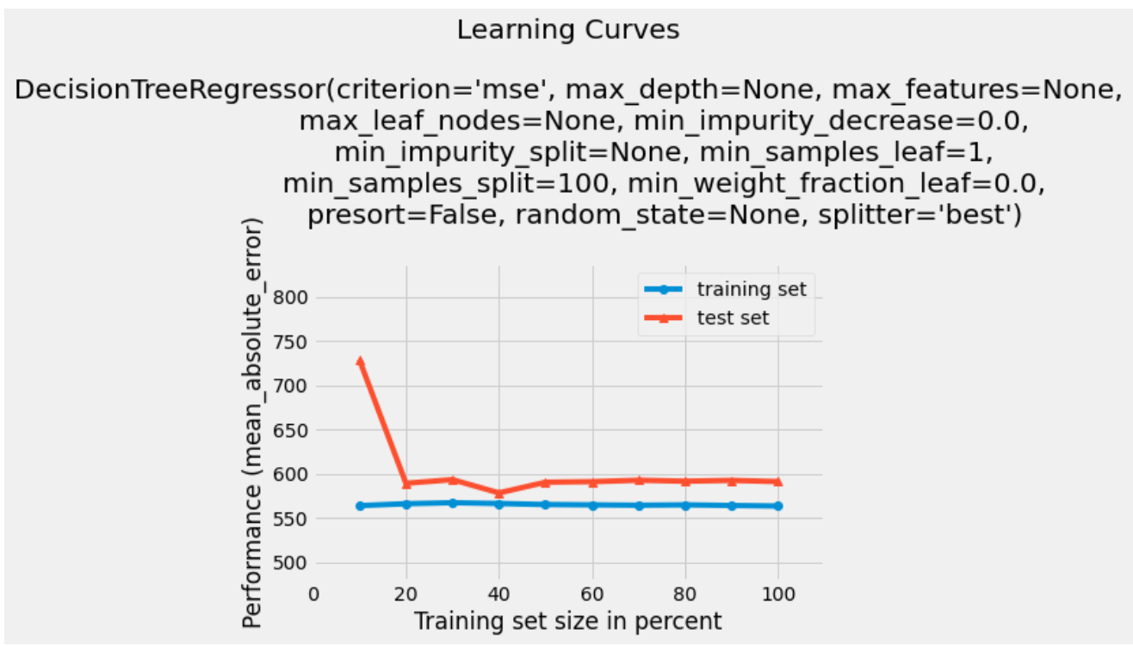

* 1. **Random Forest**

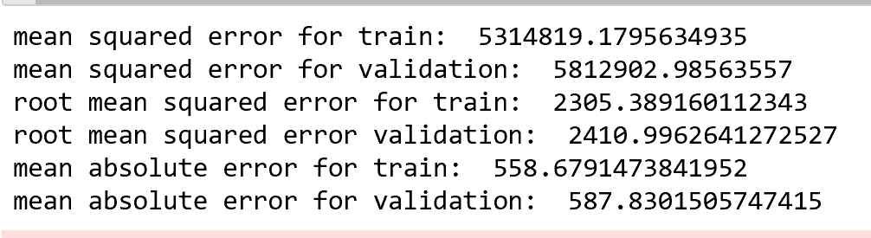

* 1. **XG Boost**

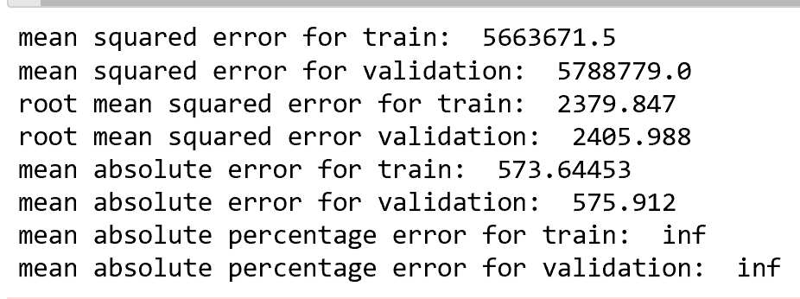

* 1. **Neural Network**

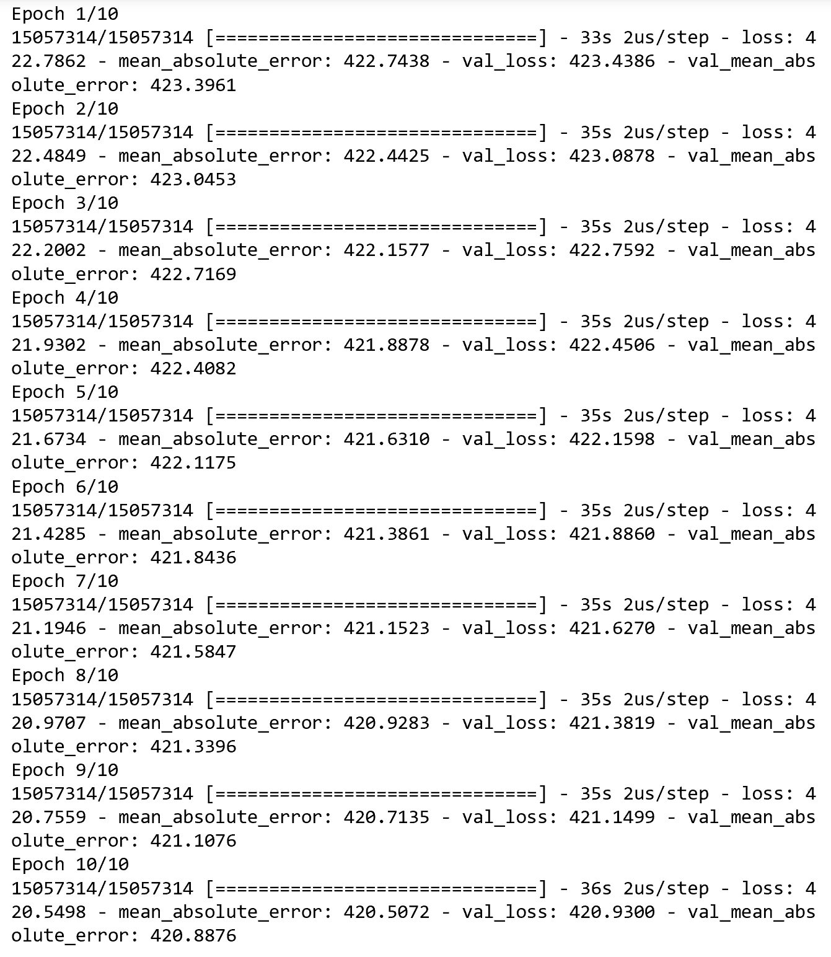

1. **Comparison of Models**

|  |  |  |  |  |  |
| --- | --- | --- | --- | --- | --- |
| Linear Regression | Random Forest | Decision Tree with Hyperparameter | Random Forest | XG Boost | Neural Networks |
| 573.8 | 587.83 | 564.6 | 574.37 | 573 | 420.88 |

1. **Yield Production Graph**

